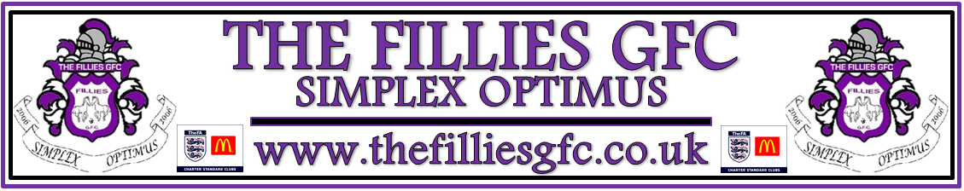

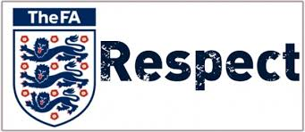 

**YOUNG PLAYERS**

**I understand that if I do not follow the Code, any/all of the following actions may be taken by my club, County FA or The FA:**

**I may:**

• Be required to apologise to my team- mates, the other team, referee or team manager

•Receive a formal warning from the coach or

the club committee

•Be dropped or substituted

•Be suspended from training

•Be required to leave the club.

In addition:

•My club, County FA or The FA may make my parent or carer aware of any infringements of the Code of Conduct

•The FA/County FA could impose a fine and

Suspension against my club.

We all have a responsibility to promote

high standards of behaviour in the game.

As a player, you have a big part to play.

That’s why The FA is asking every player

to follow a Respect Code of Conduct.

**When playing football, I will:**

• Always play to the best of my ability

• Play fairly – I won’t cheat, complain

or waste time

• Respect my team-mates, the other team,

the referee or my coach/manager

• Play by the rules, as directed by

the referee

• Shake hands with the other team and

referee at the end of the game

• Listen and respond to what my coach/

team manager tells me

• Talk to someone I trust or the club welfare

officer if I’m unhappy about anything at

my club

TheFA.com/Respect

**RESPECT CODE OF CONDUCT**