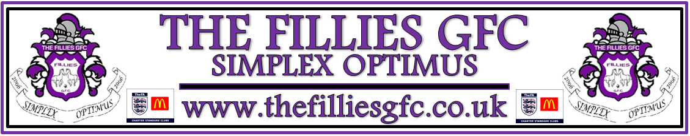

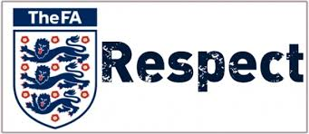 

TheFA.com/Respect

We all have a responsibility to promote high standards of behaviour in the game.

In The FA’s survey of 37,000 grassroots participants, behaviour was the biggest concern in the game. This included the abuse of match officials and the unacceptable behaviour of over competitive parents, spectators and coaches on the side-line.

Play your part and observe The Football Association’s Respect Code of Conduct in everything you do.

**On and off the field, I will:**

•Show respect to others involved in the game including match officials, opposition players, coaches, managers, officials and spectators

•Adhere to the laws and spirit of the game

•Promote Fair Play and high standards of behaviour

•Always respect the match official’s decision

•Never enter the field of play without the referee’s permission

•Never engage in public criticism of the match officials

•Never engage in, or tolerate, offensive, insulting or abusive language or behaviour

**When working with players, I will:**

•Place the well-being, safety and enjoyment of each player above everything, including winning

•Explain exactly what I expect of players and what they can expect from me.

•Ensure all parents/carers of all players under the age of 18 understand these expectations

•Never engage in or tolerate any form of

bullying

•Develop mutual trust and respect with every player to build their self-esteem

•Encourage each player to accept responsibility for their own behaviour and

performance

•Ensure all activities I organise are appropriate for the players’ ability level, age and maturity

•Co-operate fully with others in football (e.g.

Officials, doctors, physiotherapists, welfare

Officers) for each player’s best interests.

**I understand that if I do not follow the Code, any/all of the following actions may be taken by my club, County FA, league or The FA:**

•Required to meet with the club, league or

County Welfare Officer

•Required to meet with the club committee

•Monitored by another club coach

•Required to attend an FA education course

•Suspended by the club from attending matches

•Suspended or fined by the County FA

•Required to leave or be sacked by the club.

**In addition:**

•My FACA (FA Coaches Association) membership may be withdrawn.

**COACHES, MANAGERS & CLUB OFFICALS**

**RESPECT CODE OF CONDUCT**